A Day in the Life of a Holy Cross Girl
In Holy Cross Girls there are 170 pupils. In our school we have 8 classrooms for our girls. Our Principal is called Mrs McNally.
In Holy Cross Girls’ we go to our assembly hall in the mornings if we are early. Then when we go into our classroom in the mornings we hang up our coats and bags and we get our chairs out, after that we write down our homework and do the morning activity.
When I’m coming to school I put my coat on and put my bag on my back. I get a car up to school.
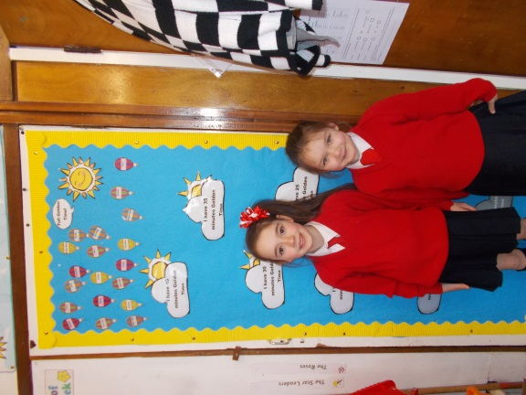
We go to break at half past10. In break we eat our fruit and play and have fun. My friends and I sometimes like to play Super Fairies. Then the bell rings, we line up, say our prayers then go into our classroom. We have Golden time on a Thursday, we have star tokens and whatever table wins gets to pick what they play with first.

I love to be in school, our topic is World War 2. I love my teachers they are Ms. Lagan and Mrs Cheung, they are very kind to us.
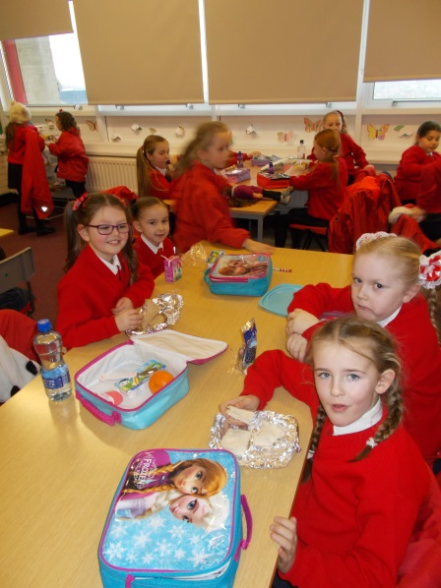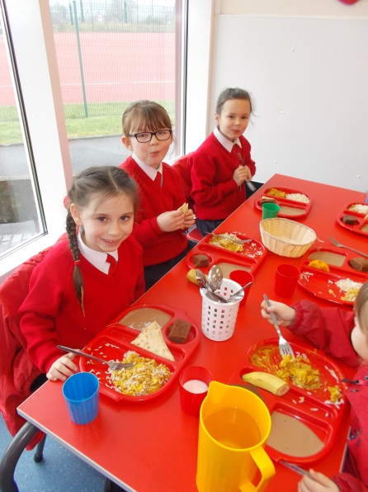
We go to lunch at 12 o’clock, we go to dinners as well. In the lunch room you have a bag with your lunch in it and in dinners the dinner lady gives you dinner on a tray. When we are done with our lunch we go out to play, we have a climbing frame.
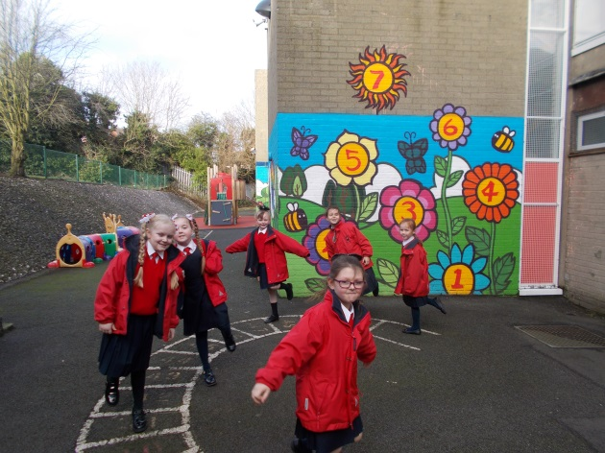
On Tuesday in the afternoon we go to singing. Our classroom is very colourful, it has everything to help you out. Our classroom is lovely and clean. I think that our school is very safe.
I think that the subjects are fun. My favourite thing is to have fun in school. I have fun and everybody else has fun too.
By AmyLouise O’Neill P4

